

**CAPSTONE PROJECT REPORT**

**Report 5 – Software Test Documentation**

– HoChiMinh, September 2020 –

**Table of Contents**

I. Project Report 3

1. Status Report 3

2. Team Involvements 3

3. Issues/Suggestions 3

II. Project Management Plan 4

1. Overall Description 4

1.1 Test Model 4

1.2 Testing Levels 4

1.3 Testing Types 4

2. Test Plan 4

2.1 Test Stages 4

2.2 Resources 4

2.3 Test Milestones 5

2.4 Deliverables 5

3. Test Cases 5

4. Test Reports 5

# I. Project Report

## 1. Status Report

|  |  |  |  |
| --- | --- | --- | --- |
| **#** | **Work Item** | **Status** | **Notes (Work Item in Details)** |
| 1 |  | Pending |  |
| 2 |  | In Progress |  |
| 3 |  | Completed |  |

## 2. Team Involvements

|  |  |  |  |
| --- | --- | --- | --- |
| **#** | **Task** | **Member** | **Notes (Task Details, etc.)** |
| 1 |  | Thaott |  |
| 2 |  | Datbc |  |
| 3 |  | Kiendst |  |
| 4 |  | Mytn |  |

## 3. Issues/Suggestions

|  |  |  |  |
| --- | --- | --- | --- |
| **#** | **Issue** | **Status** | **Notes (Solution, Suggestion, etc.)** |
| 1 |  | Pending |  |
| 2 |  | In Progress |  |
| 3 |  | Completed |  |

# II. Project Management Plan

## 1. Overall Description

### 1.1 Test Model

We use a software development process model is V-model because this model is suitable for project conditions. For each stage, there will be a corresponding check it helps us to detect errors from the beginning.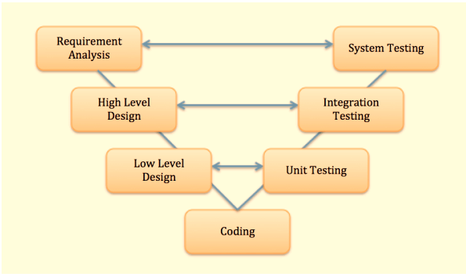

**Figure 1 - V-model**

References: *https://viblo.asia/p/v-model-trong-kiem-thu-phan-mem-la-gi-tim-hieu-voi-vi-du-sdlc-stlc-Qbq5QMEL5D8*

### 1.2 Testing Levels

**1.2.1 Unit test**

**1.2.2 Integration test**

**1.2.3 System test**

**1.2.4 Acceptance test**

**1.2.4.1 Alpha test**

**1.2.4.2 Beta test**

### 1.3 Testing Types

**1.3.1 Functional testing**

* Register
* Login
* Forgot password
* Update profile
* Change password
* Book photographer
* Edit request
* Remove request
* Review photographer (comment and rating)
* Accept request the customer
* Decline to request the customer.
* Change status request
* Add working day
* Add busy day
* The photographer edit request
* Add service
* Edit service
* Remove service
* Add album
* Edit album
* Delete album
* Open thread
* Comment thread

**1.3.2 Non-functional testing**

* Session timeout in 30 minutes.

## 2. Test Plan

### 2.1 Test Stages

|  |  |  |  |  |
| --- | --- | --- | --- | --- |
| **Type of Test** | **Stage of Test** | | | |
| ***Unit*** | ***Integration*** | ***System*** | ***Acceptance*** |
| Interface test |  | X | X | X |
| Functional test |  | X | X | X |
| Load test |  |  | X | X |
| Usability test |  |  | X | X |
| Security test | X |  | X |  |

### 2.2 Resources

#### a. Human Resources

|  |  |  |
| --- | --- | --- |
| **Worker/Doer** | **Role** | **Specific Responsibilities/Comments** |
| Trần Thiên Thảo | Leader | * Managing process * Designing database * Clarifying requirements * Prepare documents * GUI Design * Create test plan * Coding * Testing * Arrange Meeting * Risk Management |
| Bồ Công Đạt | Member | * Designing database * Clarifying requirements * Prepare documents * GUI Design * Create test plan * Coding * Testing |
| Đào Sỹ Trung Kiên | Member | * Designing database * Clarifying requirements * Prepare documents * GUI Design * Create test plan * Coding * Testing |
| Trương Ngọc Mỹ | Member | * Clarifying requirements * Prepare documents * GUI Design * Create test plan * Coding * Testing |

#### b. Environment

|  |  |  |  |
| --- | --- | --- | --- |
| **Purpose** | **Tool** | **Provider** | **Version** |
| Postman |  |  |  |
| Excel microsoft |  |  |  |
| Chrome |  |  |  |
| Mobile phone |  |  |  |

### 2.3 Test Milestones

|  |  |  |  |
| --- | --- | --- | --- |
| **Milestone Task** | **Effort (md)** | **Start Date** | **End Date** |
| Unit test |  | 20/11/2020 | 15/12/2020 |
| Test case |  | 20/11/2020 | 15/12/2020 |
| Test procedures |  | 05/12/2020 | 13/12/202 |
| Defect reports |  | 15/12/2020 | 20/12/2020 |

### 2.4 Deliverables

|  |  |  |
| --- | --- | --- |
| **No** | **Deliverables** | **Due Date** |
| 1 | Unit test | 15/12/2020 |
| 2 | Test case | 15/12/2020 |

## 3. Test Cases

* Unit Test Cases: Report5_Unit Test Case.xls
* Other Test Cases: Report5_Test Case Document.xlsx

## 4. Test Reports

Other Test Cases: Report5_Test Case Document.xlsx